Dev Diary - PRU211m

Author:

* Mai Phuong Linh
* Can Duy Khanh
* Nguyen Tuan Linh
* Mai Ngoc Giang
* Bui Quang Truong - HE163896

**Project’s name: Sunny Land Adventure**

**Unity Play Link:**

A project for the subject PRU211m of FPT University

Description: You will take on the role of Mr. Fox and venture into the quest to find your lost wife, Mrs. Squirrel. Your mission is to locate the eagle's lair and defeat it. Along the way, you will encounter lurking monsters, eliminate them, and collect items to upgrade yourself.

Mechanics: This is a 2D Adventure Platformer Game. Players will try to explore, collect points, avoid traps, destroy monsters and defeat the boss. Player uses A,W,S,D to move, Space-bar for jumping, L-Shift for dashing, F for interacting with buttons and treasures, and J,K for attacking.

Beside, there is a demo level for 2 players which Mrs,Squirrel can join to adventure with Mr.Fox. Player 2’s movement using Numpad that 4,8,5,6 for moving, 0 for jumping, . for dashing and 7 for interacting with buttons and treasures.

p/s: 2 Players level is just a demo so that might have some bugs but it doesn’t affect the game.

DevLog: <https://docs.google.com/document/d/1pEqEBnjLkPiJ94HdMME2JBqsSnEcz8mmFiA-rrkSJE4/edit?usp=sharing>

Source code: …

Thank you for playing the game. Leave feedback if you can.

### **Task 1: Basic**

1. Open Unity: Version LTS 2021.3 25f1
2. Assets:

* Sunny Land: <https://assetstore.unity.com/packages/2d/characters/sunny-land-103349>
* Sunny Land Woods: <https://assetstore.unity.com/packages/2d/environments/sunnyland-woods-129708>
* Pixel Font - Thaleah:   
  <https://tinyworlds.itch.io/free-pixel-font-thaleah>
* Free Casual Game SFX Pack: <https://assetstore.unity.com/packages/audio/sound-fx/free-casual-game-sfx-pack-54116>
* 2D UI Health Bar:  
  <https://fliflifly.itch.io/hearts-and-health-bar>
* And some images, sounds from the internet.

1. Player’s movement:

* Basic movement
* First, to make the player move left and right, we move the player by getting the value of the horizontal axis from the keyboard or various input devices.

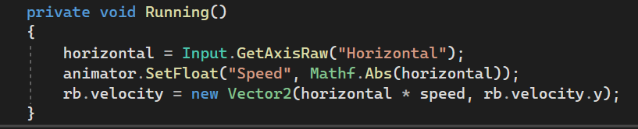

* There is a small problem when moving that the player’s sprite is not flipping. So if the player is moving left, that means the sprite must face into the left side and vice versa, same with the right side. To check it, we simply check the value of the horizontal axis and rotate the player’s transform.

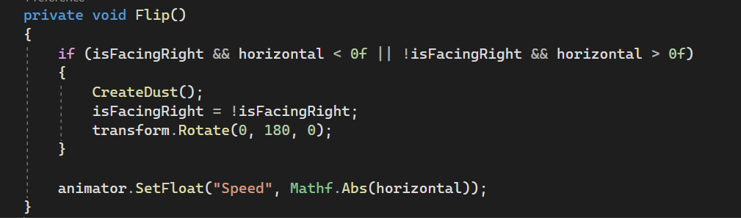

* Then, for jumping. We firstly check if the player is on the ground or not by checking to see if any object is within a specific circular area on the 2D plane.

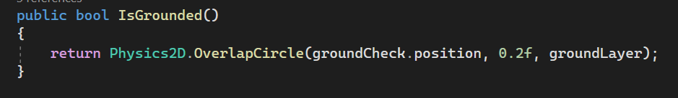

* If the player is on the ground, it can jump by using AddForce or make a velocity for the player in the vertical axis. Here, we use velocity. Besides, if the player has already jumped once and hasn’t touched the ground yet, the player can jump once more which is called “Double Jump”.

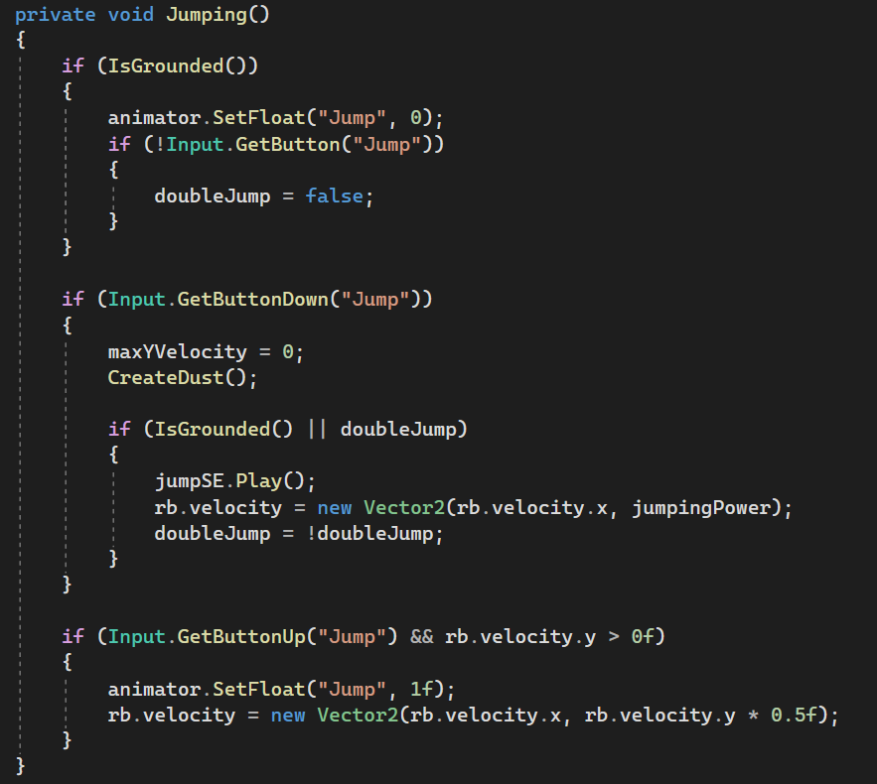

* To make the player have the ability of dashing, we use the same idea with jumping but this time is with the horizontal axis and in the IEnumerator function because we don’t want the player to dash continuously . We also make a Trail Renderer behind the player to make it more realistic.

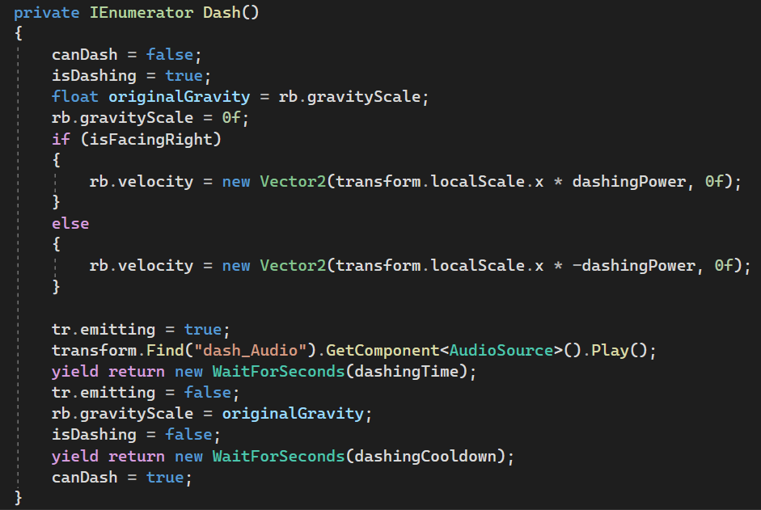

* To be more physically realistic, when the player falls from a high distance, we make the player hurt by falling damage and bounce a little bit. We considered that the player got falling damage while it is falling, which means the velocity is negative and only if the player is not jumping, here we choose -18.   
  * *The player’s health will be explained in more detail below.*

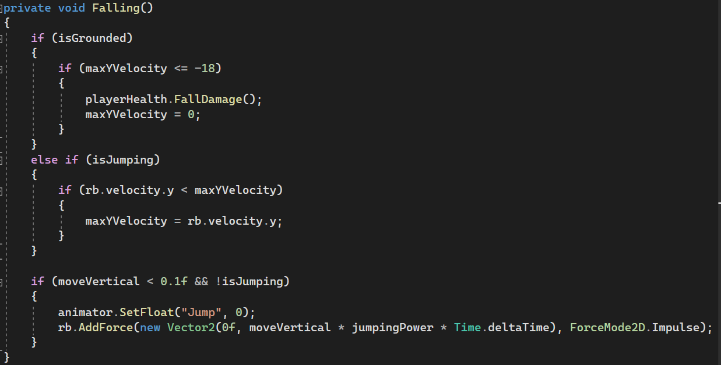

* Advanced movement:
* In level 4 of story mode, we would like the player to be able to interact with walls which means slide the wall, wall jumping. Firstly, we would like to check whether the player is near the wall (of course the wall will have the “Wall” layer) or not. We also use the same idea with ground check.

